INTERNSHIP PROJECT REPORT
(Project Term January-April, 2019)

QUESTION PAPER GENERATOR

Submitted by

Name of Student - Harshita Trivedi Registration Number :11504428

Course Code –CSE 441

Under the Guidance of
SHILPA MAHAJANI
(INDUSTRY SUPERVISOR)

School of Computer Science and Engineering



Company Mentor End Term Evaluation Form
DECLARATION
I hereby declare that the project work entitled (“QUESTION PAPER GENERATOR”) is an authentic record of our own work carried out as requirements of Internship for the award of B.Tech degree in COMPUTER SCIENCE AND ENGINEERING from Lovely Professional University, Phagwara, under the guidance of (Anita Rananaware), during (19 January to 01 May 2019). All the information furnished in this capstone project report is based on my own intensive work and is genuine.
Name of Student : HARSHITA TRIVEDI
Registration Number: 11504428

(Signature of Student )
Date:
CERTIFICATE
This is to certify that the declaration statement made by the student is correct to the best of my knowledge and belief. He / She has completed his / her internship under my guidance and supervision. The present work is the result of his / her original investigation, effort and study. No part of the work has ever been submitted for any other degree at any University. The internship is fit for the submission and partial fulfillment of the conditions for the award of B.Tech degree in COMPUTER SCIENCE AND ENGINEERING from Lovely Professional University, Phagwara.

Signature and Name of the Mentor - SHILPA MAHAJANI

Designation (INDUSTRY SUPERVISOR)

School of Computer Science and Engineering,
Lovely Professional University,
Phagwara, Punjab.

Date :
ACKNOWLEDGEMENT
The internship opportunity I had with Cognizant Technology Solutions Pvt. Ltd. was a great chance for learning and professional development. Therefore, I consider myself as a very lucky individual as I was provided with an opportunity to be a part of it. I am also grateful for having a chance to meet so many wonderful people and professionals who led me through this internship period.
I express my deepest thanks to Mrs. Shilpa Mahajani as Industry Supervisor for taking part in useful decision & giving necessary advices and guidance and arranged all facilities to make internship easier and successful. I choose this moment to acknowledge her contribution gratefully. It is my radiant sentiment to place on record my best regards, deepest sense of gratitude to Mrs. Anita Rananaware, section Mentor, for her careful and precious guidance which were extremely valuable for my study both theoretically and practically. I perceive as this opportunity as a big milestone in my career development. I will strive to use gained skills and knowledge in the best possible way, and I will continue to work on their improvement, in order to attain desired career objectives. Hope to continue cooperation with all of you in the future.

Sincerely,
Name: Harshita Trivedi
Place: Pune, Hinjewadi
Date:

TABLE OF CONTENTS

COVER PAGE…….………………………...……………….…………………….……..…………….…..1
PAC FORM…….………...…………………...……………………………………………….……….…..2
DECLARATION………………………………….………...……………………………...……………..3
CERTIFICATE……………………………………………………………………………...……………
ACKNOWLEDGEMENT………………….……………………………………………...….……....…..4
TABLE OF CONTENT…….………………...……………………………………………… …..............5
1. INTRODUCTION………………………………………...……………………...…....………………...7
2. PROFILE OF PROBLEM……………………………..……………………………….………….……8
2.1 PROJECT TITLE………………………………………...……………………………..….…....……8
2.2 OBJECTIVE………………………………………………...……………………………………....…8
2.3 PROBLEM…………………………………………………...……………………………………...…8
2.4 SOLUTION……………………………………………………...…………………………………......8
2.5 SIGNIFICANCE…………………………………………………...…………………………….…….8
3. EXISTING SYSTEM………..…………………………………………..……………………......….......9
3.1 INTRODUCTION………………...………………………………………………………....……...…9
3.2 EXISTING SOFTWARE…………………………………...………………………………………..9
3.3 DFD FOR CURRENT SYSTEM………………………...…………………………………….........10
3.4 WHAT’S NEW IN THE SYSTEM TO BE DEVELOPED…...…………………………………..11
4. PROBLEM ANALYSIS……………………………………………..….…………..……………..…...11
4.1 PRODUCT DEFINITION……………...…..…………………………………………………..…...11
4.2 FEASIBILITY ANALYSIS....................................................................................................…........11
4.3 PROJECT PLAN…………………………….……………………………………………….……..12
5. SOFTWARE REUIREMENT ANALYSIS……...………………………………………….......……13
5.1 INTRODUCTION……………………………………..………………………………………….....13
5.2 GENERAL DESCRIPTION…………………………………………………………………...........13
5.3 SPECIFIC REUIREMENTS…………………………………………………………………..…....14
5.3.1 HARDWARE CONFIGURATION…………...………………………………........…………..14
5.3.2 SOFTWARE CONFIGURATION……………...…………………………………………..….15
6. DESIGN………………………………………………………………………………..……...………. 16
6.1 SYSTEM DESIGN………………………………………...………………………………….….....16
6.2 DESIGN NOTATIONS……………………………………………………………………..………17
6.3 DETAILED DESIGN……………………………………………………………………….…........18
6.4 FLOW CHARTS……………………………………………………………………………….....19

(vi)
7. TESTING………………………………………………………….……………………………....….. 20
7.1DEFINITION………………………………………………………………………...……………...21
7.2 TESTING TYPES IN PROJECT………………………………………………...……………….21
7.2.1 FUNCTIONAL TESTING…………………………………………………...………………...21
7.2.2 STRUCTURAL………………………………………………………………...………………22
7.2.3 USABILITY TESTING……………………………………………………...………................22
7.2.4 INTERFACE TESTING……………………………………………………………………….23
7.2.5 COMPATIBILITY TESTING…………………………………………………….…..……....24
7.2.6 PERFORMANCE TESTING………………………………………………………………….25
7.2.7 SECURITY TESTING………………………………………………………………………....25
7.3 LEVELS OF TESTING……………………………………………………………………..……..25
8. IMPLEMENTATION……………………………………………………………………...………...25
8.1 IMPLEMENTATION OF THE PROJECT…………………………………………..…...…….26
8.1.1 COLLECTION OF DATA…………………………………………………………….....…....27
8.1.2 REQUIREMENT ANALYSIS………………………………………………………………...27
8.1.3 DIVISION OF MODULES……………………………………………………….………...…28
8.2 CONVERSION PLAN…………………………………………………………….……….…...…28
8.3 POST-IMPLEMENTATION AND PROJECT MAINTENANCE………………..…….……..28
9. PROJECT LEGACY…………………………………………………………….…………….…….29
9.1 CURRENT STATUS OF THE PROJECT………………………………………………….…...29
9.2 REMAING AREAS OF CONCERN………………………………………………………..........29
9.3 TECHNICAL AND MANAGERIAL LESSIONS LEARNT…………………………………...29
10 SNAPSHOTS………………………………………………………....…………………………….30-38
11 BIBLIOGRAPHY……………………………………………………………………...……………39
1. INTRODUCTION

In this system we present a smart question paper generating system. In our system we allow administrator to input a set of questions and respective answers for option ticking. We also allow admin to provide marks, language and complexity for each of these questions. After this the questions are stored in database along with their marks and language. Now on question paper generating time the admin just has to select the language. On this selection the system selects questions randomly in a way that admin choose the language. We allow admin to add more admins and more skills as well as questions.
On the user side user can sign up and after authentication in a system user take test within a given period of time and he or she can view all available tests and their previous report. Based on the marks scored in the test he/she can work on particular skill according to the bar graph shown.
- Efficient question paper generation.
- No chance of paper leaks.
- No need of transporting papers through police/security vans to all organizations.
- The system provides an unbiased result.
- Thus the system excludes human efforts and saves time and resources.
Simplify process through automation :
Before QPG System Batch owner have to take test manually for trainee’s but this is making
automated as we can take test easily.

Create greater efficiency:

It is more efficient as it reduces manual work. QPG tool utilizes the time as the tool is automated.

Reduce manual work:

Taking tests manually and then checking answers actually takes a lot of efforts but QPG Tool Reduces all that manual Work.

Facilitate tracking:

User can also view the previous results so they can work on particular skill by using this system.

2. PROFILE OF PROBLEM

2.1 PROJECT TITLE

Question Paper Generator(QPG).

2.2 OBJECTIVE

Our main objective is to help organization to take test and making manual work easy.

2.3 PROBLEM

Before QPG System Batch owner have to take test manually for trainee’s but this is making
automated as we can take test easily.It is more efficient as it reduces manual work. QPG tool utilizes the time as the tool is automated. Taking tests manually and then checking answers actually takes a lot of efforts but QPG Tool Reduces all that manual Work. User can also view the previous results so they can work on particular skill by using this system.

2.4 SOLUTION
- Efficiently takes test.
- No need of transporting papers through any security vans to all organizations.
- The system provides an unbiased result.
- No chance of paper leaks.
- Easily evaluates trainee’s performance.
- Can work on particular skill based upon results.
Thus the system excludes human efforts and saves time and resources.

2.5 SIGNIFICANCE

The idea of QUESTION PAPER GENERATOR is very significant considering the fact that it’s a kind of plateform where you need not to go anywhere you can directly work on particular skills and can check your understandings on some skills. It helps organization or universities evaluating performance of employees/students or trainee’s. In this system On the user side user can sign up and after authentication in a system user take test within a given period of time and he or she can view all available tests and their previous report. Based on the marks scored in the test he/she can work on particular skill according to the bar graph shown. We present a smart question paper generating system. In our system we allow administrator to input a set of questions and respective answers for option ticking. We also allow admin to provide marks, language and complexity for each of these questions. After this the questions are stored in database along with their marks and language. Now on question paper generating time the admin just has to select the language. On this selection the system selects questions randomly in a way that admin choose the language. We allow admin to add more admins and more skills as well as questions.

3. EXISTING SYSTEM

3.1 Introduction

We have designed smart question paper generating system. In our system we allow administrator to input a set of questions and respective answers for option ticking. We also allow admin to provide marks, language and complexity for each of these questions. After this the questions are stored in database along with their marks and language. Now on question paper generating time the admin just has to select the language. On this selection the system selects questions randomly in a way that admin choose the language. We allow admin to add more admins and more skills as well as questions. On the user side user can sign up and after authentication in a system user take test within a given period of time and he or she can view all available tests and their previous report. Based on the marks scored in the test he/she can work on particular skill according to the bar graph shown.

3.2 Existing Software

Currently taking tests manually is so tough as it’s a waste of paper and there is huge chance of paper leak and it takes a lot of human efforts and time taken. As creating paper manually and then checking each one’s answer takes time and efforts and needs a lot of resources.

3.3 DFD for present system

Level 0

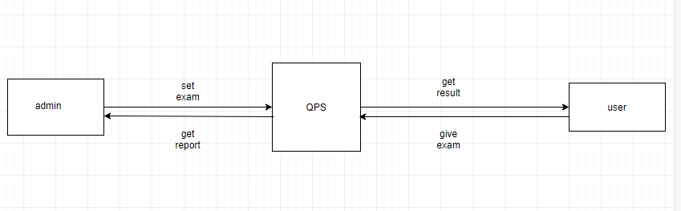

Level 1

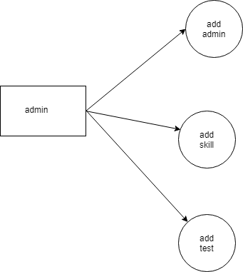

Level 2
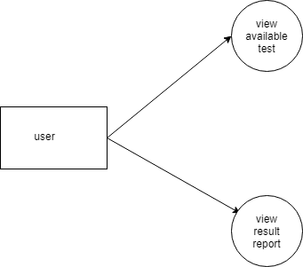

3.4 What’s new in the system to be developed?

It is essential for every organization to have a knowledge evaluation platform to measure the depth of subject knowledge of its employees. The “question paper generator” application is intended to serve the purpose. The objective is to develop a smart question generation system that will be able to generate assessment questions based on the course complexity and knowledge level of the assesses. Allow the organization to update the questions in case of manual
intervention and conduct assessments for its employees. The application will also have the features to automatically evaluate the assessments and display graphical reports

4. PROBLEM ANALYSIS

4.1 PRODUCT DEFINATION

- It helps organization or universities evaluating performance of employees/students or trainee’s. We have designed smart question paper generating system. In our system we allow administrator to input a set of questions and respective answers for option ticking. We also allow admin to provide marks, language and complexity for each of these questions. On the user side user can sign up and after authentication in a system user take test within a given period of time and he or she can view all available tests and their previous report. Based on the marks scored in the test he/she can work on particular skill according to the bar graph shown.

4.2 FEASIBILITY ANALYSIS

The whole process of creating question paper, was done manually till date. Processing the question paper i.e. researching and allocating the weight to the questions is a tedious task till date. Drawbacks of current systems The current system is very time consuming.it is very difficult to analyze the questions manually. Too much time is consumed in the process of creating question papers of more subjects. So many questions are evaluated before finalizing the questions for the question paper. The chances of paper leakage are more in current system as compared to proposed system. Paper processing takes more time as it is done manually. B. Proposed System The automatic question paper generator has following features: In comparison to the present system the proposed system will be less time consuming and is more efficient. Analysis will be very easy in proposed system as it is automated. The question paper which is generated, will be accurate to the administrator’s input. The proposed system is very secure as no chances of leakage of question paper as it is dependent on the administrator only. The generated question paper can be edited to suit the requirements.

4.3 PROJECT PLAN

Automatic Question Paper Generator is special software which is useful to schools, Institutes, organizations who want to have a huge database of questions and generate test papers frequently with ease. It mainly deals with the gathering, sorting and administration of a large amount of questions about different levels of toughness from scientific as well as non-scientific subjects related to various classes. This paper introduces the usage of shuffling algorithm in Automatic Question Paper Generator System to overcome the mentioned problem. The main part of the shuffling algorithms is to provide randomization technique in question paper generation system, thus different sets of question could be generated without repetition and duplication. One can make many sets of paper from one database. This software assures no duplicity of questions in database. Questions will have marks weight upon which the administrator can generate various question paper sets, having questions with different marks weight. Question paper is generated with great ease and accuracy in less than a minute. Also, the concern remains is how the current technologies would also help the instructors automatically generate the different sets of questions from time to time without being concern about repetition and duplication from the past exam while the database keeps growing. These automated systems provide cost saving and time-efficient solutions. Automated system has proved to be very much helpful in generating question paper rather than doing it by itself by the organizations.

5. SOFTWARE REUIREMENT ANALYSIS

5.1 Introduction

- It helps organization or universities evaluating performance of employees/students or trainee’s. We have designed smart question paper generating system. In our system we allow administrator to input a set of questions and respective answers for option ticking. We also allow admin to provide marks, language and complexity for each of these questions. On the user side user can sign up and after authentication in a system user take test within a given period of time and he or she can view all available tests and their previous report. Based on the marks scored in the test he/she can work on particular skill according to the bar graph shown.

5.2 General Description

FUNCTIONAL REQUIREMENTS

1. Take Test

A platform which can take test to check performance of employees and employee’s can work on particular skill in which they are lacking behind.

2. See Available Test

User can see all the available tests which are active at particular time.

3. See Report

This function will help user to see all the reports and marks of the test which are given by them.

4. Add Admin

This function helps admin to add more admins to conduct tests.

5. Add Skill

This function will allow admin to add skills in which admin want user to attempt test.

6. Add Questions

This function will allow the admin to add questions according to skill and level.

7. Select Level

This function will allow the admin to select level for each question.

8. Select Skill

This function will allow the admin to select skill for each question.

9. Assign Marks

This function will allow the admin to assign marks for each question on basis of that total marks will be calculated.

10. Set Timer

This function will allow the admin to set time for particular test.

REQUIREMENT

1. Availability

The data/system should be available 24*7. It should be available and can be accessed anytime and from anywhere.

2. Backup

System should have a regular backup plan. So that It can be recovered if data crash or any unexpected things happens.

3. Capacity

System should be capable of handling large traffic and the response time should be reasonable. It should not have unexpected behavior at peak time.

4. Security

System should be secured. Only, authorized person can access the crucial data and should have authority to change the data. No other users should have access to it. It should be highly secured and data integrity should be maintained as well.

5. Reliability

System should be reliable. If certain unexpected things happen, admin should be able to fix it.

6. Performance

This is most important requirements in system design. Performance of the system should be optimal. It can be maintained by high uptime, throughput and faster accessibility.

5.3 Specific Requirements

5.3.1 Hardware Configuration

RAM: 2GB and above

Hard Disk: Minimum for installing a browser

5.3.2 Software Configuration

Operating System: Windows 7, 8, 8.1, 10, linux Database: MySQL

Browser Supported

Google Chrome

Internet Explorer 8

Mozilla Firefox

Microsoft edge

Safari

6. DESIGN

Development of the project “Question Paper Generator” organization requires.

6.1 System Design

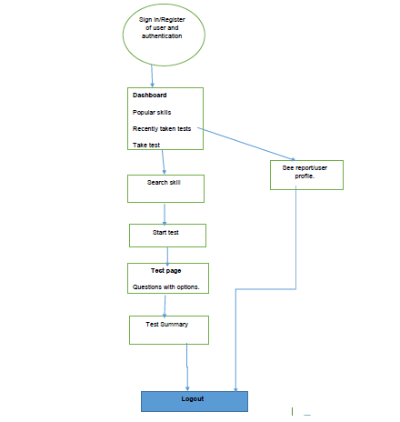

6.2 Design Notations

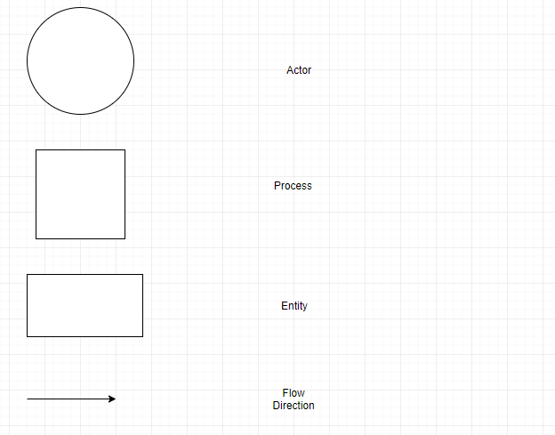

6.3 Detailed Design

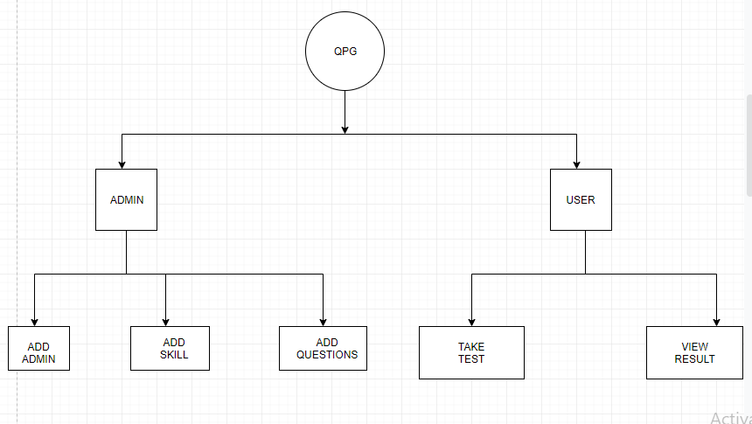

6.4 Flow Charts

Analysis Flow Diagram

7. TESTING

7.1 DEFINITION

Testing is the process of executing a system code with the intent of finding an error and correcting those errors. It is defined as the process in which defects are identified, analyzed, isolated, and subjected for rectification and ensured that product is defect free in order to produce the quality product and hence customer satisfaction. The quality is defined as justification of the requirements. Defect is nothing but deviation from the requirements and bug. Testing can demonstrate the presence of bugs, but not their absence. Debugging and Testing is not the same thing there is minor difference between these two. Testing is a systematic attempt to break a program. Debugging is the art or method of uncovering why the script /program did not execute properly.

The main objectives of testing are:

- Testing is the process of executing a program with the intent of finding errors.

- A good test case is one that has the high probability of finding the undiscovered errors.

- A successful test is one that uncovers all the undiscovered errors.

Testing Methodologies:

- Black box (Functional) Testing: is the testing process in which tester can perform testing on an application without having any internal structural knowledge of application. Usually Test Engineers are involved in the black box testing. In this we have tested the input and output directly without any knowledge about the coding section. Like proper displaying of contents along with formatting.

- White box (Structural) Testing: is the testing process in which tester can perform testing on an application with having internal structural knowledge. Usually The Developers are involved in white box testing. In this, testing of each module performed with the proper knowledge of internal structure of module.

- Grey box Testing: is the process in which the combination of black box and white box testing performed simultaneously.

7.2 TESTING TYPES IN PROJECT

- Functionality Testing

- Structural Testing

- Usability Testing

- Interface Testing

- Compatibility Testing

- Performance Testing

- Security Testing

7.2.1 FUNCTIONAL TESTING

- Under this section we tested all the major components of the project.

- The contents are being fetched and displayed properly on the front end.

- System is functioning with all types of browser in desktop.

- Available Tests are displaying properly under ‘see available tests’ tab.

- Analyzed data and graphs are displaying the analysis accurately according to marks.

- All the tabs and links are functioning as specified and also responding quickly.

7.2.2 STRUCTURAL TESTING

Structural test design techniques include:

Control flow testing

Whether the flow of control of the code is in order i.e. Level wise? Yes, flow of control of the code is functioning as specified in documentation and user can move anywhere throughout the website at any time.

Data flow testing

Does the data flow between two blocks or within a block occurs? Is it flowing as needed or any bugs are present? Yes, Data is flowing among the modules. Contents are displaying properly and API is also fetching the scores of users.

Statement coverage testing

Has each statement in the program been executed? Yes, each statement of the program is covered and all the modules are working properly.

Branch flow testing

Tests whether each branch of each control structure has been executed or not. For example, in if statement whether both the true and false branches been executed or not. Yes, all the branch in the program is executing as per condition specified.

Condition coverage testing

Has each Boolean sub-expression evaluated both to true and false or not? Yes, all the conditions in the program is being covered as per condition applied.

Path testing

Has every path through a program been executed at least once or not? Yes, every path is verified and it is executing at least once.

7.2.3 USABILITY TESTING

Testing for Navigation: Navigation means how user browses the website and explore the features available in the website like pages, buttons, menu bar, images, videos and graphs etc. Main menu is provided in each page for easy navigation.

Content Testing: Contents are easy, simple and understandable. Checked for spelling in the content. Checked for colors which annoys the user. Followed all the standard rules of application content development. Errors in fonts, colors, themes etc., should be verified. Contents are meaningful and attractive.

7.2.4 INTERFACE TESTING

The main interface in the system is the login page, admin and user page. Score of the students is coming through API and data are coming from database server Checked all the connection among these interfaces are connected well and working properly. Errors are handled properly. If database interface gives any error, then server application should show the error messages.

7.2.5 COMPATIBILTY TESTING

Compatibility testing is very important aspect of any project. It contains:

- Website compatibility

- Operating system compatibility

- Analysis frame compatibility

- Database compatibility

- Images and video compatibility

7.2.6 PERFORMANCE TESTING

- The system loading and fetching all contents from the server for proper functioning.

- All the modules are functioning properly and displaying the contents.

- HTML, CSS, and java Script codes are performing well and fetching contents properly.

- Design, colors and frames are also working as specified.

- All the links available in the website is performing accurately

- All the images are displayed spontaneously.

7.2.7 SECURITY TESTING

- Test by pasting domain name directly into browser to check whether modification can be done or not without login.

- Try invalid inputs in input fields by selecting wrong id and password and check whether they are validating correctly or not.

7.3 LEVELS OF TESTING

- Unit testing: Testing the modules or a specific section of code individually.

- Integration testing: After individually testing modules they are integrated and again go through integration testing

- Regression testing: Focuses on finding defects after a major code change has occurred.

- Smoke testing: This consists of minimal attempts to operate the software, designed to determine whether there are any basic problems present in the system that will prevent it from working at all.

- Performance Testing: Performance testing is the testing to assess the speed and effectiveness of the system and to make sure it is generating results within a specified time as in performance requirements.

- Usability Testing: This testing tests the GUI whether it is user friendly or not. Whether it is easy to understand or not.

- A/B testing: It is basically like: run a test, change one thing, run the test again, compare the results. This is more useful with more small-scale situations, but very useful in fine-tuning any program.

- System testing: Testing the complete system as whole.

- Installation testing: An installation test assures that the system is installed correctly and working at actual customer's hardware.

- Alpha testing: It’s an actual operational testing by potential users or an independent test team known by the developers. Alpha testing is often internal acceptance testing, before the software goes to beta testing.

- Beta testing: The software is released to groups of people (mostly general users) so that further testing can ensure the product has few faults or bugs.

8. IMPLEMENTATION

Implementation is the final and important phase of software development. The most critical stage is in achieving a successful new system and in giving the users confidence that the new system will work and be effective. The system can be implemented only after thorough testing is done and if it found to working according to the specification. Implementation is the stage in the project where the theoretical design is turned into the working system and is giving confidence to the new system for the users i.e. will work efficiently and effectively. It involves careful planning, investigation of the current system and its constraints on implementation, design of method to achieve the changeover, an evaluation of change over methods. A part from planning, major task of preparing the implementation is to educate the targeted users. The more complex system is designed, the more complex will be the system implementation and publicity effort required.

There are three types of implementation:

- Implementation of a computer system to replace a manual system.

- Implementation of a new computer system to replace an existing system.

- Implementation of a modified application to replace an existing one, using the same computer.

8.1 IMPLEMENTATION OF THE PROJECT

The implementation type of this project falls under the first type of different categories of implementation discussed in the above introduction of this section i.e. implementation of a computer system to replace a manual system.

After the completing the designing, development and in-house & alpha-beta testing phases of the application; the implementation phase will be carried out in the following major steps:

8.1.1 Collection of Data

The first and foremost requirement of the website is the collection of data for analysis. We have collected data from database and after calculation it is showing the accurate result in front end.

8.1.2 Requirement Analysis

After collecting the data, we have analyzed the requirement of the software and we have all the documentation of the requirement.

8.1.3 Division of Modules

We have divided the software into modules and distributed among ourselves, after that we have implemented and tested all the modules individually as well as integrally.

8.2 CONVERSION PLAN

First and foremost, data was collected, after data collection, documentation, and division of modules we have implemented all the modules like home page, user page and admin page.
We have connected all the pages properly and added the required poles in database.

8.3 POST-IMPLEMENTATION AND PROJECT MAINTENANCE

Post Implementation: Monitoring all the storage area from My sqlsever datatbase. Functioning of all the modules properly and updating the module as per requirement.

Project Maintenance:

Maintenance is the enigma of the project development. Almost 60% effort goes into maintenance part. It holds the Data Science industry captive, tying up programming resources. Analysts and programmers spend much more time in maintaining programs than they writing them. Though maintenance is not considered a part of software development, but it’s an activity that’s extremely important in the life of a website.
1. Corrective Maintenance:

After the Implementation, correcting the residual errors if any. If such errors are discovered, the source of it should be detected and removed. We have to correct the errors related to website. This phenomenon falls under corrective maintenance.

2. Perfective Maintenance:

Sometimes changes in the system has to be done according to the organization requirements. We have to make changes in our system in order to make it perfect by finding and fixing bugs. This type of changes to the system is called perfective maintenance.

3. Adaptive Maintenance:

System often must be upgraded and enhanced to include more features as per requirement and provide more services. This also requires modification of the System so that it can adapt the environment in which it is going to run.

9. PROJECT LEGACY

9.1 CURRENT STATUS OF THE PROJECT

Our project Question Paper Generator is working properly. In this system we present a smart question paper generating system. In our system we allow administrator to input a set of questions and respective answers for option ticking. We also allow admin to provide marks, language and complexity for each of these questions. After this the questions are stored in database along with their marks and language. Now on question paper generating time the admin just has to select the language. On this selection the system selects questions randomly in a way that admin choose the language. We allow admin to add more admins and more skills as well as questions. On the user side user can sign up and after authentication in a system user take test within a given period of time and he or she can view all available tests and their previous report. Based on the marks scored in the test he/she can work on particular skill according to the bar graph shown.

9.2 REMAINING AREAS OF CONCERN

Adding questions automatically from other resources.

So far what we have developed and deployed is just a basic structural project which is capable of taking tests and checking performance of users and in future what we can add is, adding questions automatically form resources as in current project we are entering the questions in database manually and then picking it randomly according to skill and level.

Real time graph:

Right now the graph that we are displaying in our system is directly the screenshot of graph that we are getting from scores and according to knowledge of users.

Detailed report:

In our website we are just taking tests and showing the scores according to the given tests and bar analysis to help in future for particular skill in which user is lacking behind.

9.3 TECHNICAL AND MANAGERIAL LESSONS LEARNT

This project has benefited us in many ways. The first benefit is that we have got a deep knowledge of web development languages, ASP.NET, ADO.NET ,C#, HTML , JavaScript and it has provided us with an opportunity to know the knowledge of employees as well. It has helped us to sharpen our knowledge and skills, develop better appreciation of practical problems of organizations. This experience is going to help each of us immensely in further learning of advanced concepts in other project development and to plan our career in the light of practical experiences. We have examples to relate and it will facilitate better and easier learning for us. Since our project is a based on ASP.NET, ADO.NET and C#.

Technical lessons learnt

- Installation and usage of visual studio.

- Knowledge of Web Development languages

  - HTML

  - CSS

  - Java Script

  - Bootstrap

- Use of ASP.NET

Managerial lessons learnt

- Ensuring quality and integrity of data

- Planning of Duration and schedule of the project

- Strategic planning to avoid miscommunication among the team members

- Participative Leadership

- Allocating resources

- Coordination

- Risk Analysis and prevention

- Integrating individual work to make it collaborative work

- Defining smaller goals to achieve a bigger common goal

- Organizational Exposure and an insight to the business

10. USER MANUAL

Here is a prototype on how the ‘User Registration’ and other pages looks like.



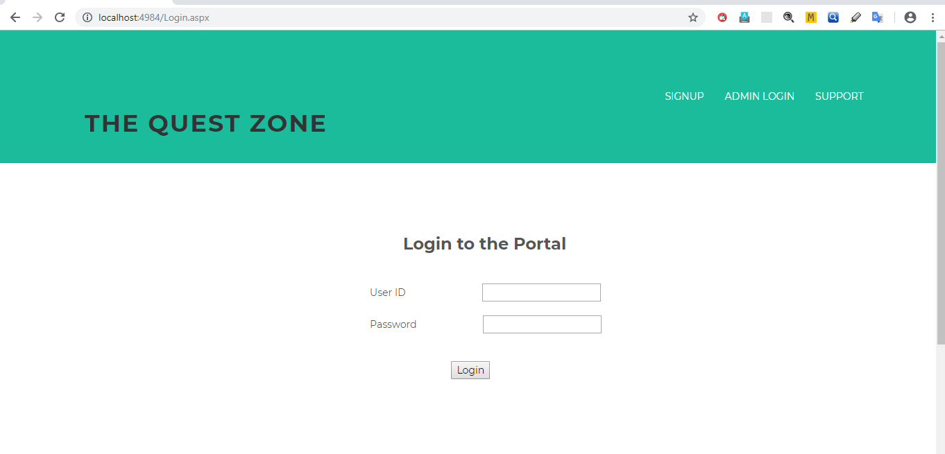

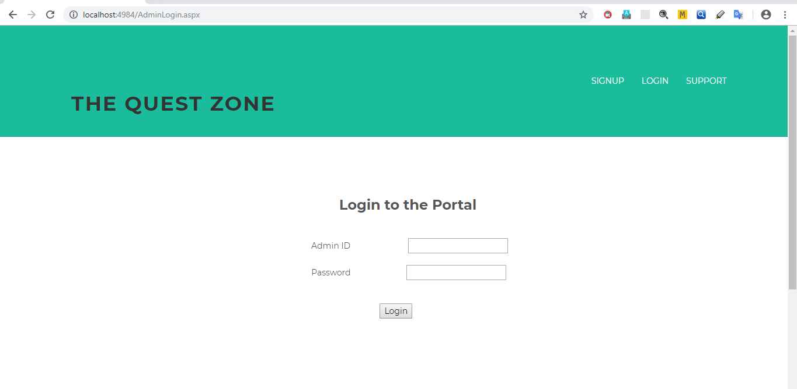

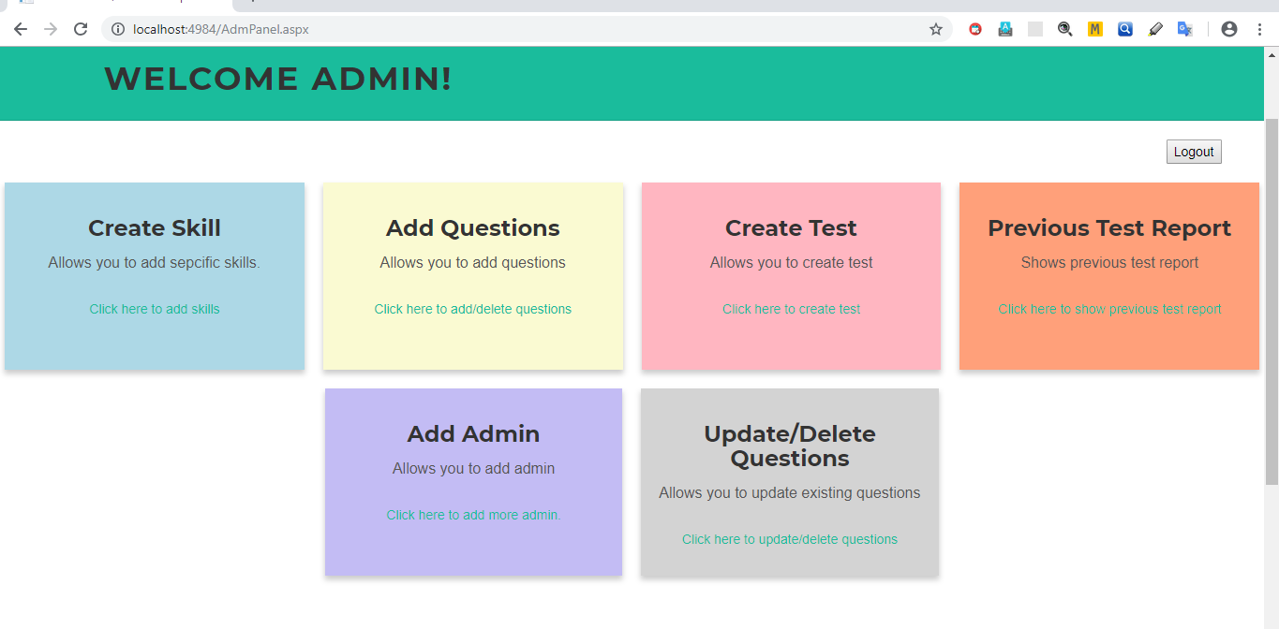

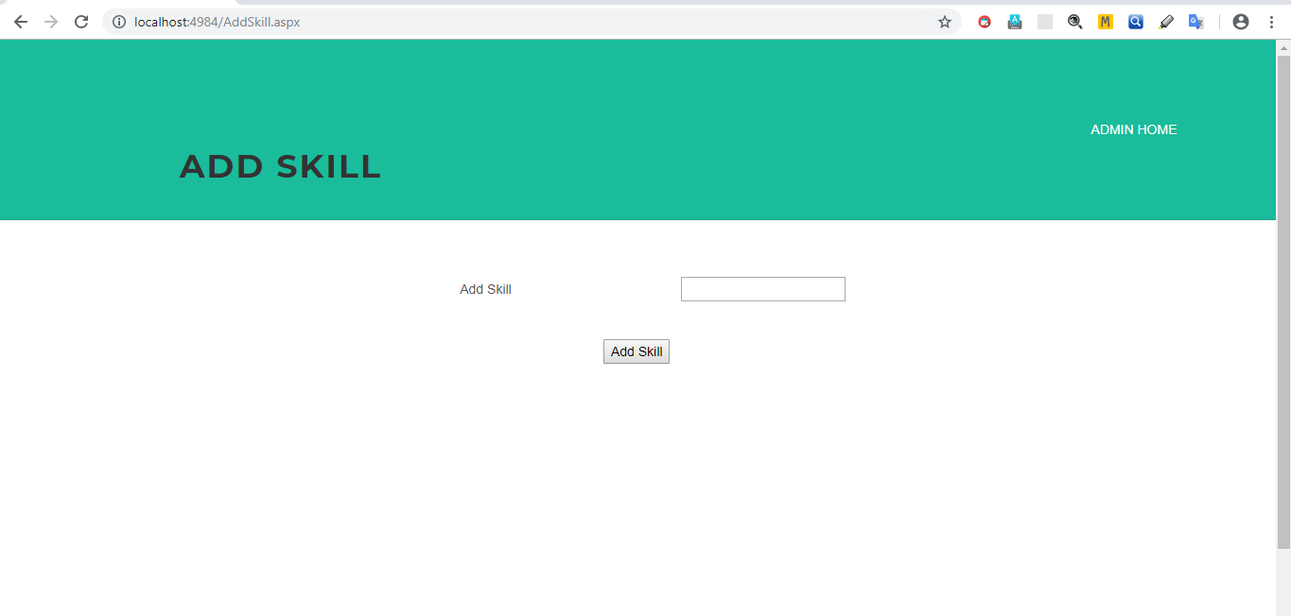

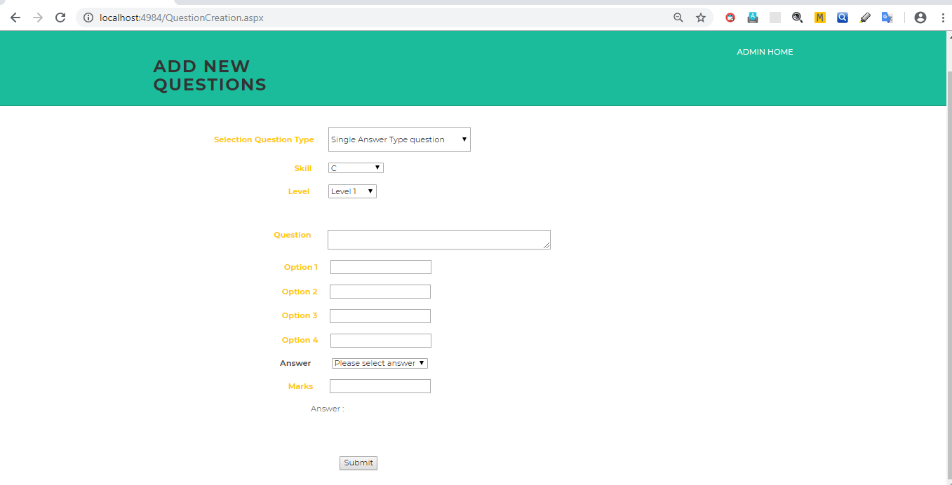

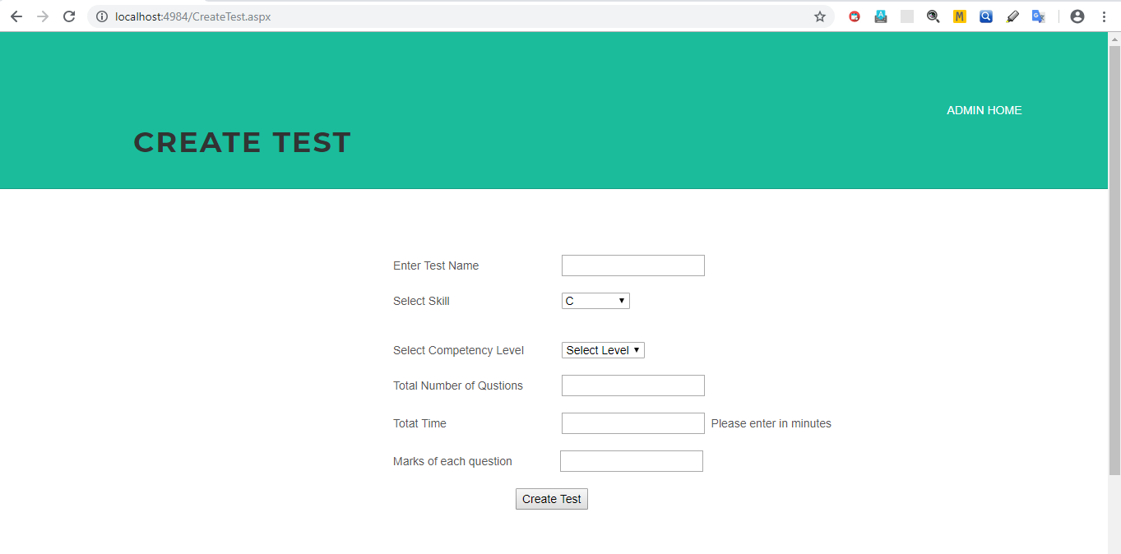

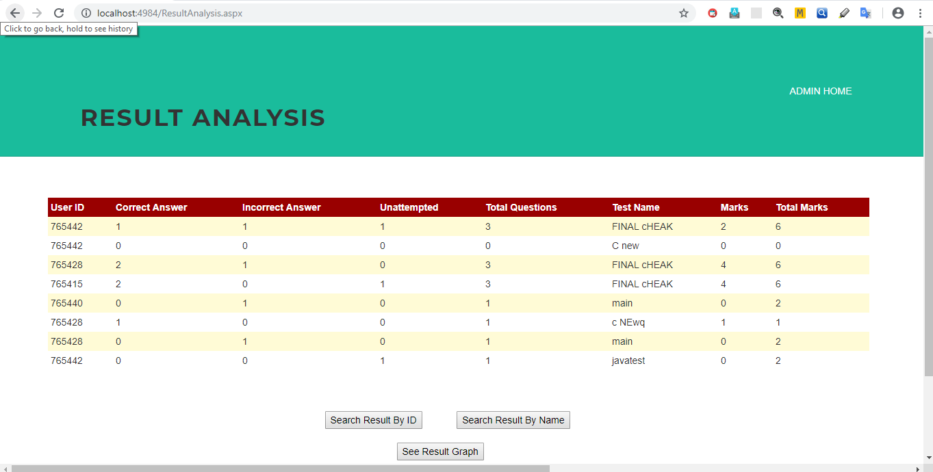

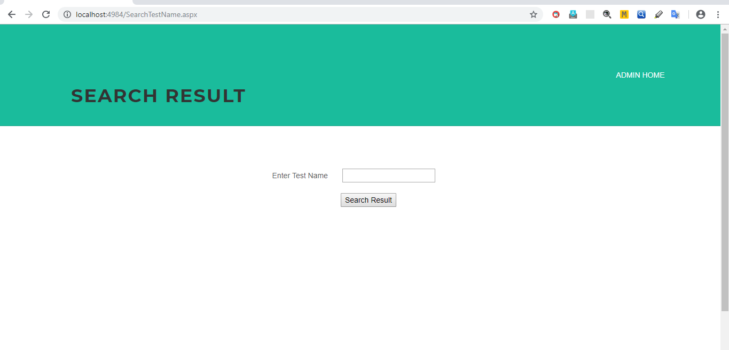

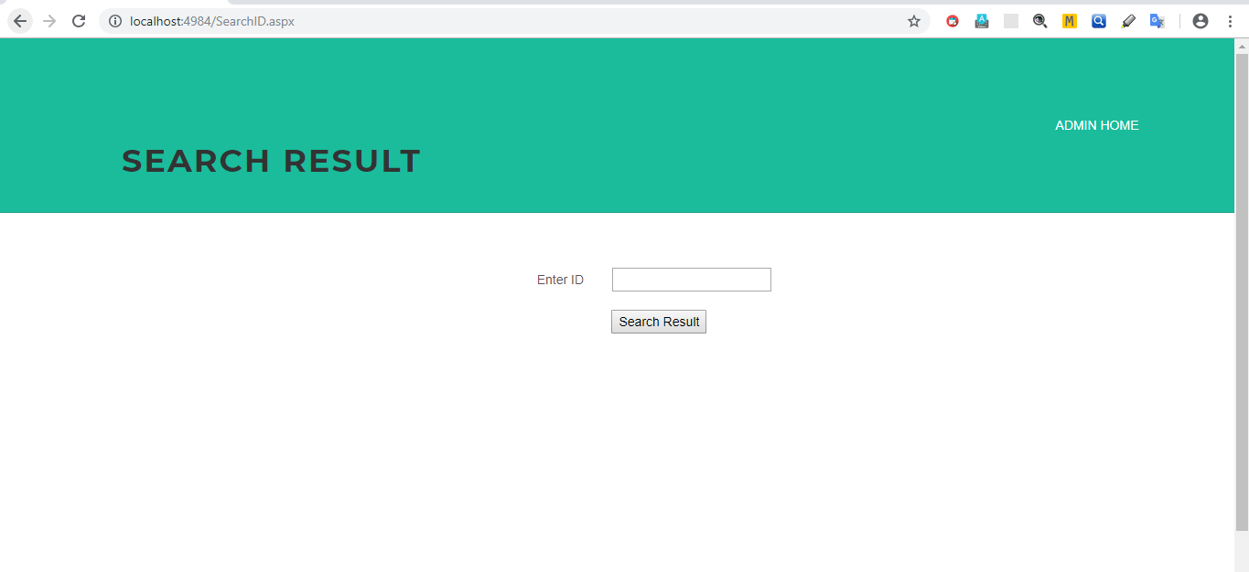

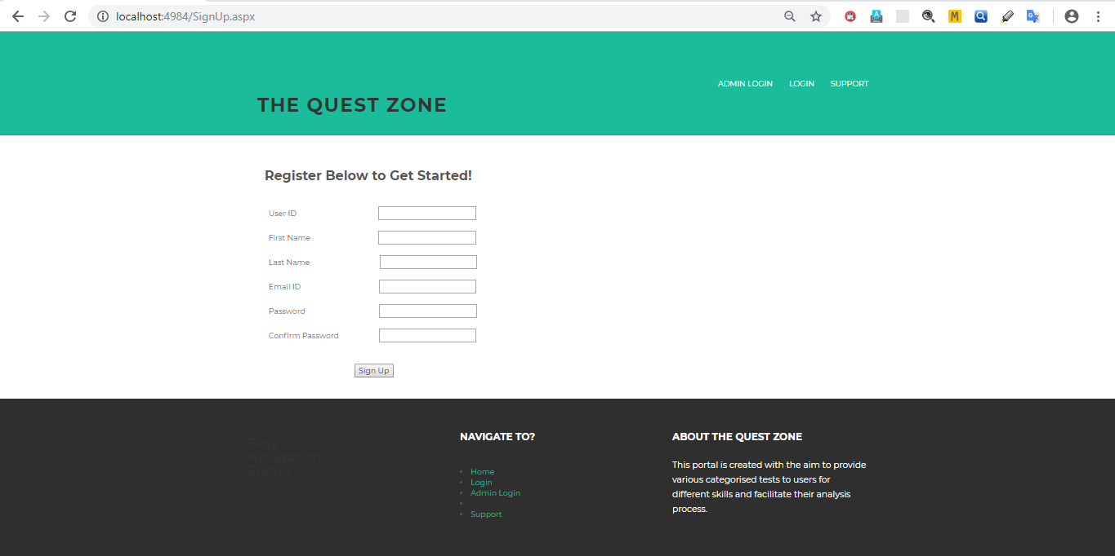

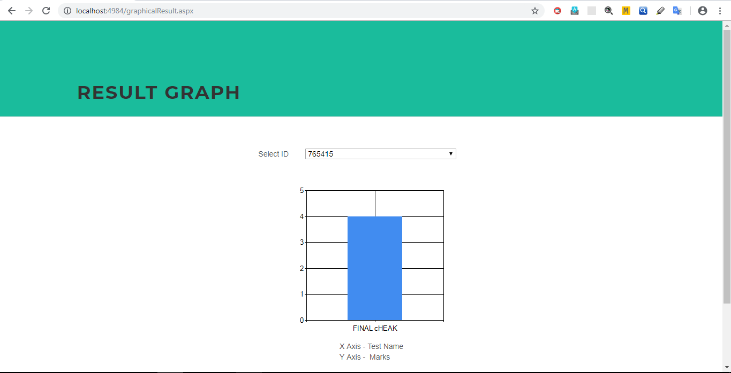

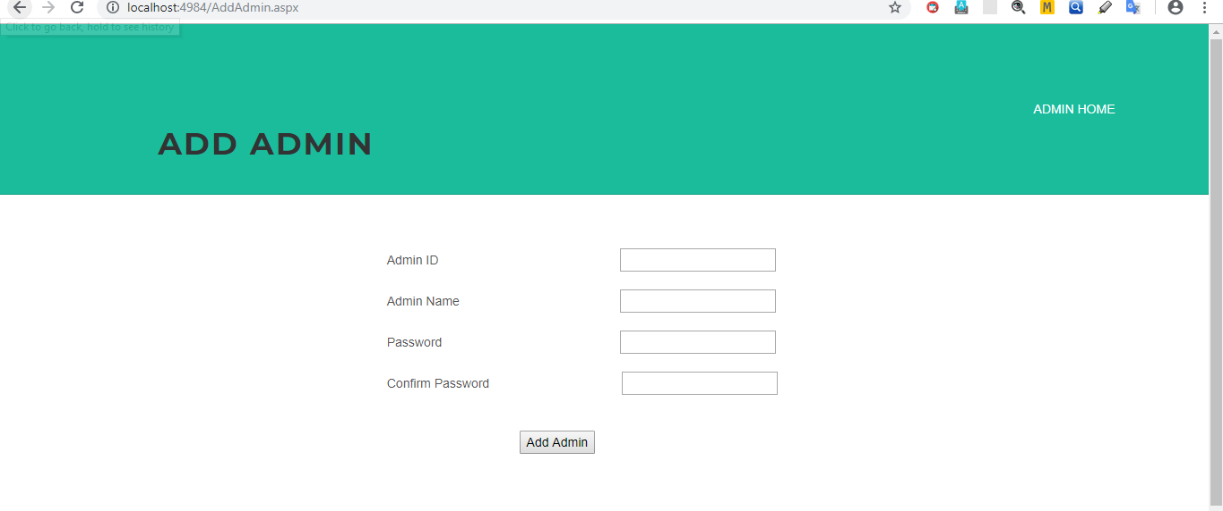

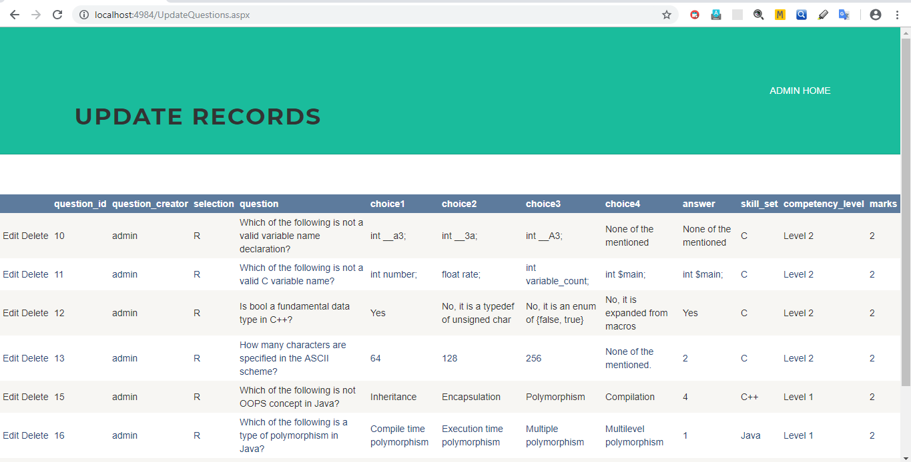

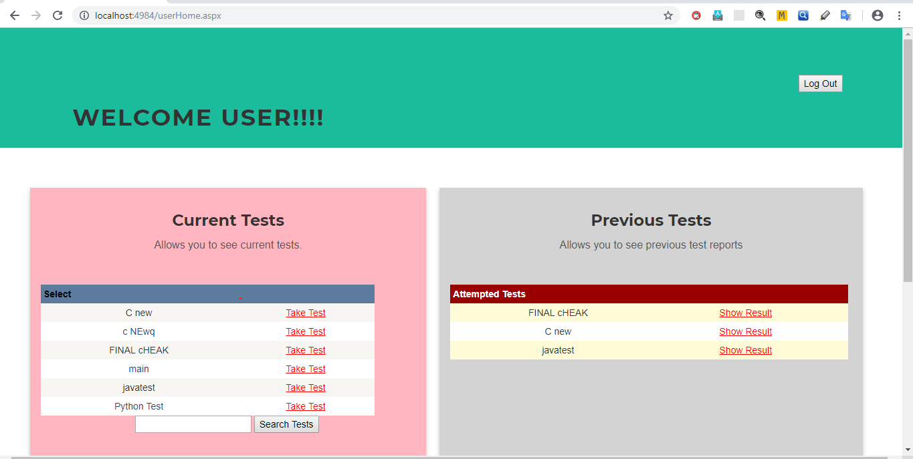

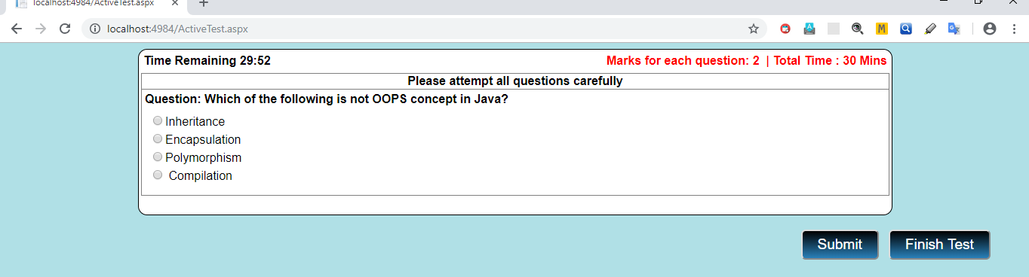

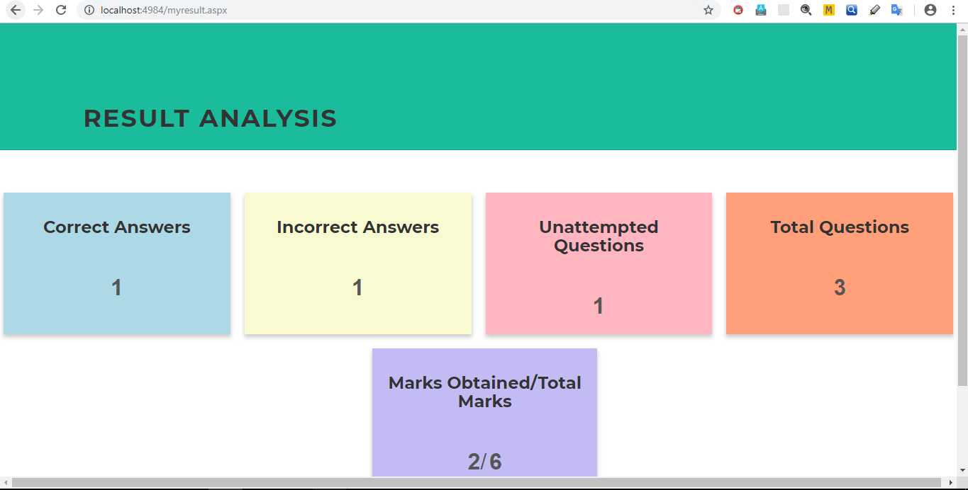

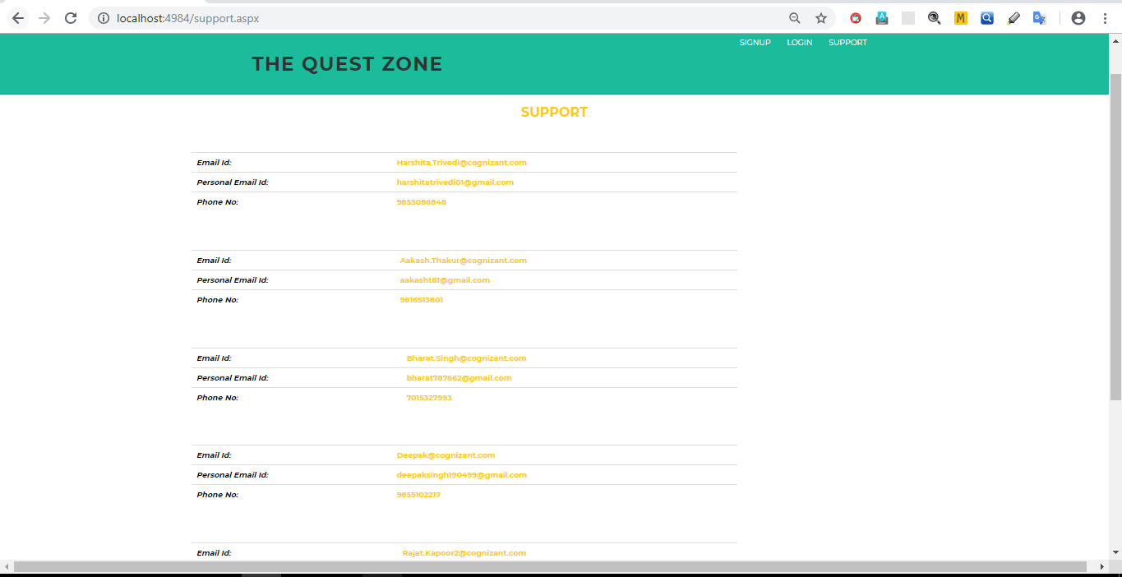

12. BIBLIOGRAPHY

- www.google.com
- https://www.w3schools.com
- https://stackoverflow.com
- https://docs.microsoft.com/en-us/dotnet/csharp

